

Computer Science 301

**Web Technologies**

**Practical 2: Week beginning 12 October 2020 [60 Marks]**

**Part I: Tables, Forms and Basic CSS [50]**

1. Create the following table with all the formatting. You are required to do the following: [30]
2. Use appropriate tags.
3. Apply all the formatting you see in the table below. You have to use appropriate to technique to avoid repeating css rules. For example, the row coloring shown in the figure below shouldn’t be assigned to each affected row (as much as possible). You can choose any other color instead of the yellow and blue.
4. The title at the heading of the table is linked to the table. You can see this by resizing the browser. So, use appropriate tag to achieve this effect.

Note: part of the text that you can use to enter into the table is included in prac2q1.txt file.

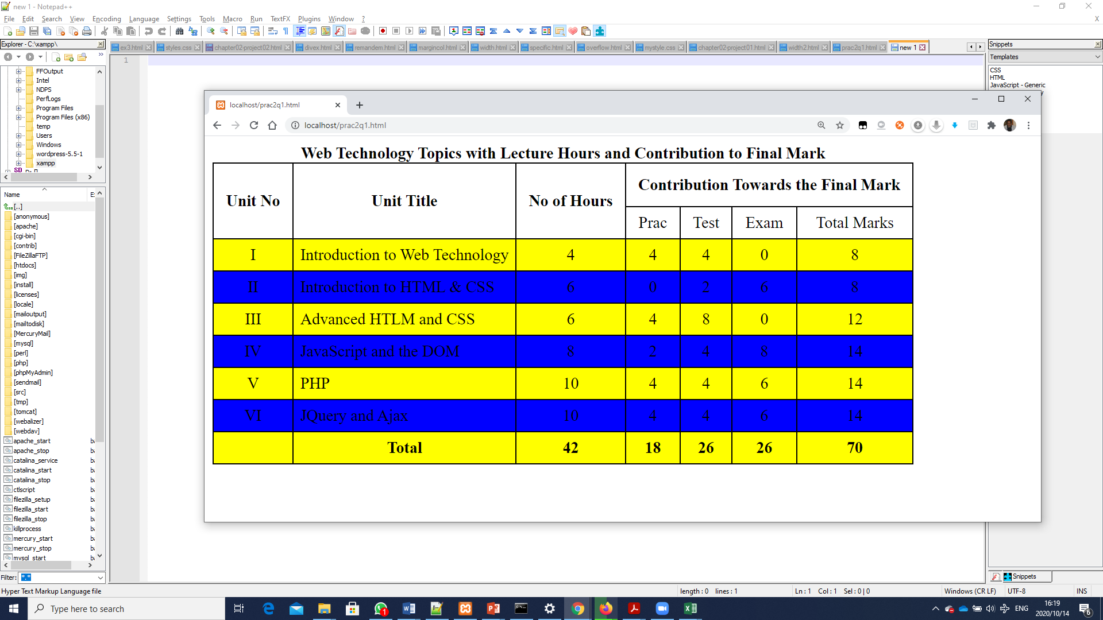

1. Edit prac2q2.html and prac2q2.css files that you can find in the resources folder so the page looks similar to that shown below: [20]
2. Create the form and position the elements by placing them within a table. While we do not believe that this is best practice, legacy sites often use tables for layout so it may be sensible to get some experience with this approach. In the next chapter, you will learn how to use CSS for layout as a better alternative.
3. For the drop-down lists, add a few sensible items to each list. For the checkbox list, they should be an array of elements. Notice also that this form makes use of a number of HTML5 form elements.



The form, when submitted to the server for processing (calling the process.php), the data the information retrieved by process.php looks like the following (next page). Using this information, name the different form elements and attributes accordingly.



**Part II: Advanced CSS: Layouts [30]**

1. Demonstrate your proficiency with absolute positioning and floats by modifying prac2q3.css so that prac2q3.html looks similar to that shown in the figure on the next page.

Instructions

1. Examine prac2q3.html in the browser. The HTML does not need to be modified for this project. You will create the three-column layout using absolute positioning and margin settings as discussed in class (read the section “Using Floats to Create Columns”).
2. Within the main column, the company and client addresses will use floats rather than positioning.
3. Within the boxes for recent messages, weekly changes, and top sellers, you will need to use floats, block display, and padding values.

**Note**: Be sure to test by increasing/decreasing the browser zoom level. If you have used em units for font sizes and most margin and padding values, it should scale to the different zoom levels.

The images are included in the resource folder by maintaining their path.

